Web UI Design Doc

Carla, Montana, & Riona

# Research of Existing Websites

## [Absolut Vodka](https://www.absolut.com)

### Usability

The Absolut Website is quite easy to use but could definitely be better. The drinks are able to be found on the main menu by scrolling down, along with some other options the user may be looking for. The rest of the pages can be found after clicking on the hamburger menu at the top left. However, the phrasing and lack of a search feature are a major issue in my opinion. In the menu there is a page called “Drinks”, which you would assume is where you buy the products as a company that sells drinks, but it actually brings you to a social page with cocktail recipes called “Absolut Drinks”. The drinks that are sold are actually found at the very bottom of the menu under “Products”. I really dislike this design decision as the user is always going to read the first category before the “Products” one and click onto the wrong page.

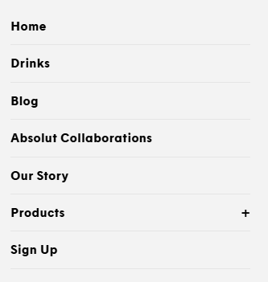

### Responsiveness

This website adjusts seamlessly to smaller screen sizes, not cutting off any images unnecessarily and turning the selection of drinks into a rotating carousel to keep everything visible and accessible. Everything stays at a reasonable size and is easy to use, with some menus and buttons growing or changing completely when on mobile to stay usable.

The website works perfectly on a wide screen, however, on mobile while everything works as intended there is a lot of content that must be scrolled through before you reach the drinks (the main point of the website). The number of images is no issue on a wide screen but because on mobile they are moved to all be below each other you must scroll a lot to pass them all.

### Accessibility

The Absolut Website is very accessible for the most part, with alt text attached to all their images and suitable names for all the buttons and titles. The background and foreground also contrast enough to be visible to the majority of people and the text is sufficiently spaced and sized for people who may struggle reading. This website lacks accessibility however because of it difficulty to be navigated using only a keyboard, while it can be navigated, you are brought through a bunch of unnecessary and unselectable language options and images before reaching the top of the actual page.

### Aesthetics

I like the aesthetics of this website and think that it matches the "vibe” that they are trying to give off very well. The only thing I don’t like is the amount of images on the home screen making you scroll past them to get to the main content of the website and causing it to look quite cluttered, especially on mobile where all the images are placed below each other without much size changing. However, besides this I think the website looks great. The style is very consistent everywhere you go and doesn’t make it difficult to browse the website in any way.

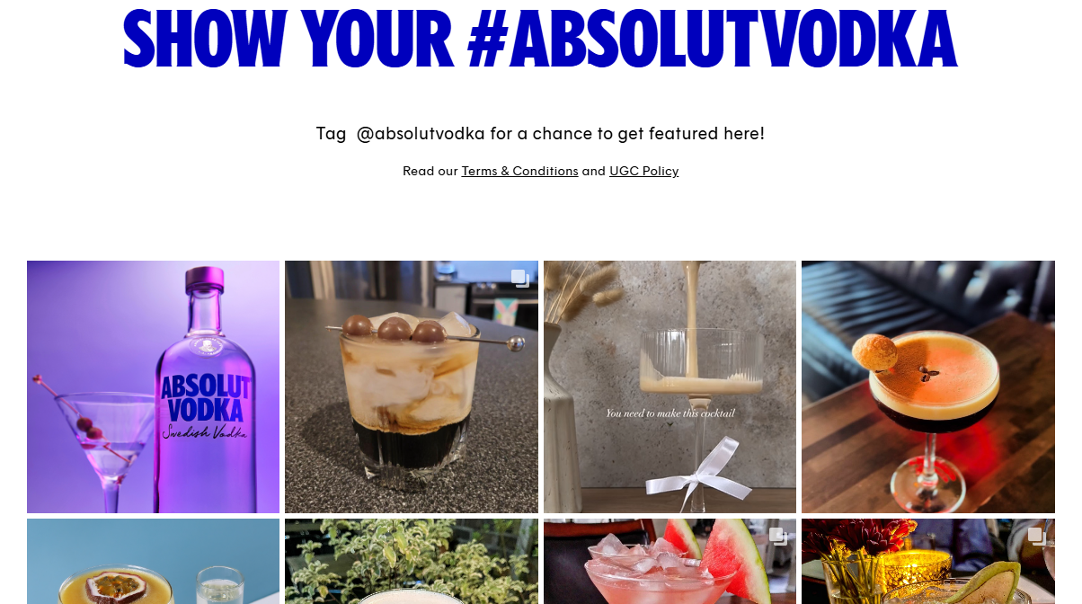

### Content Quality

The content here is well structured and simple to understand, and I have found no mistakes within this content. Everything is organised into its correct categories and is easy to find for the most part. My only complaints would, again, be the images that I have talked about before as they feel more like advertisements than informative content, and how the “Products” category is not found at the top of the category list, despite being the primary purpose of the website.

### Interactivity

This website is as interactive as it needs to be in my opinion. The only interactivity found on this website are the hover effects, age form on entry, and updating blog and social media feed, but I think that this is all it needs for the type of website that it is. The age form is a necessity for a website that sells alcohol, such as this, and this one is very efficient with its automatic moving to the next box and closing of the menu when the form is completed.

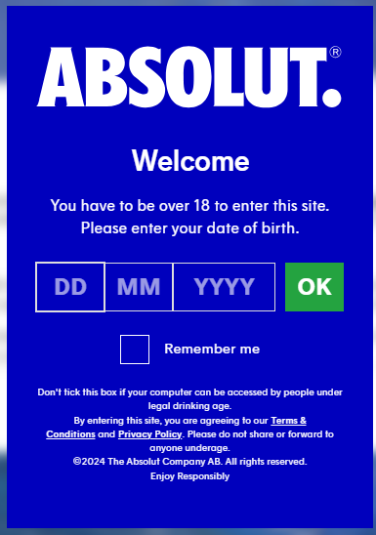 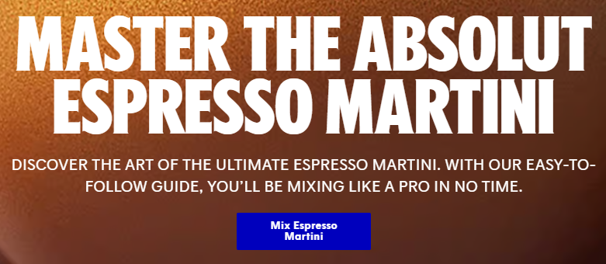

The hover effects are alright, just changing colour, moving a bit, or growing when the mouse is over it, my only issue is that some of the images on this website include buttons that seem like they could be hovered over but are actually static images which is quite unsatisfying. And finally I think the social media feed is a great idea for the type of wesbite that they are trying to create where they can off how ingrained they are with their “community” and consumers.

### Consistency

This website is very consistent, only 2 fonts are used (besides some small parts where different fonts are used for stylistic purposes) and while the images are very colourful, the website elements stick to white or a consistent dark blue. The layout also stays mostly the same on every page with the only change being the category selection panel at the top moving and changing format a bit. Consistent branding is also found on every page and interactions stick to the same format and style everywhere. Images in a similar style with similar placement are also found everywhere, keeping the pages looking uniform and making sure that every page feels like part of one website rather than disconnected parts.

### Comparison & Conclusion

|  |  |  |
| --- | --- | --- |
| **Features** | **Pros** | **Cons** |
| * Carousel Showcase * Social Media Feed * Age Form * Hover Effects * Background Contrast | * Consistent Design * Fun & Relatable Style * Sense of Community * Accessible (mostly) * Effectively Showcases Products | * Visually Cluttered with unnecessary images * Awkward Wording & Category Layout * Inaccessible to users who only use keyboard |

Overall, this is not a bad website by any means. Despite how much I talked about the issues, most of my complaints were caused by the same few things that are easily fixable and there are still a lot of features of this website that I do enjoy, as seen above. I think that this website achieves what it is trying to pretty well by selling drinks and fostering a community and with a few changes this website could be perfect for that intention.

## [Arizona Tea](https://drinkarizona.com/?srsltid=AfmBOor9kCbk2ZBrijUXBD8LAGCEAZodWB6tK5sXgvfsiyg4JT_NcCux)

### Usability

Arizona provides easy access to products right away from the homepage, making it its primary focus all throughout. It’s composed of big buttons and icons that’ll easily catch the reader's attention which, in addition to the colour palette chosen to make the website visually focused with the shop and information clearly divided. This avoids any confusion between different subheadings and sections as they’re clearly divided making use of the website’s own colour palette both on mobile and a laptop.

### Responsiveness

The website offers a very fast and swift response to any user input with no delays. All interactions occur smoothly. There are no visual glitches that may cause the website to be an annoyance rather than a tool for the user.

### Accessibility

Extremely detailed website, offering both mobile and laptop users an accessibility icon at one of the bottom corners of their screen. This button allows you to adjust the website according to your needs and preferences and provides translations to different languages. However, this translation feature is only available for the settings the button provides, meaning it’ll only translate those from one language to another. The website’s language will remain in English unless you search for the platform that matches your region. Another downfall is this brand is heavily focused on the American market. These comparisons are being made considering the American website but if we go to the European one, they have linked in their hamburger menu, it barely offers any services. They only provide the ability to purchase merch from the European site.

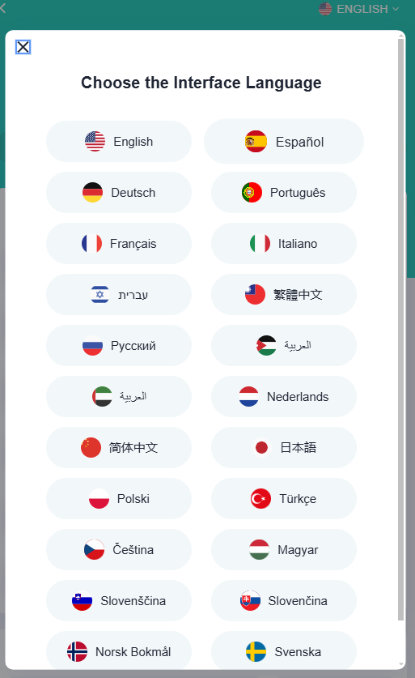

### Aesthetics

There's a clear colourful and consistent palette all throughout with the brand’s colours and typical popular branding colours that’ll easily catch a customer’s attention. Such as green, pink, white and black. They also make use of big bold text which contrasts with the products’ slimmer fonts, putting the focus and each heading. It is heavily imaged and visually focused that catches anyone’s attention. The usage of different tones of the same colour to differentiate hamburger menu parts also makes it easier for those with impairments that make it hard for them to read big chunks of text cluttered together. Overall, it creates a visually engaging yet clean and neatly put together look, which aligns with the branding style of colourful and fun drink flavours. Despite its organization, some may still consider the homepage to be quite cluttered as there is only any usage of white space when showcasing the products. Additionally, the homepage mainly focuses on its merchandise before showcasing the products which can be an annoyance.

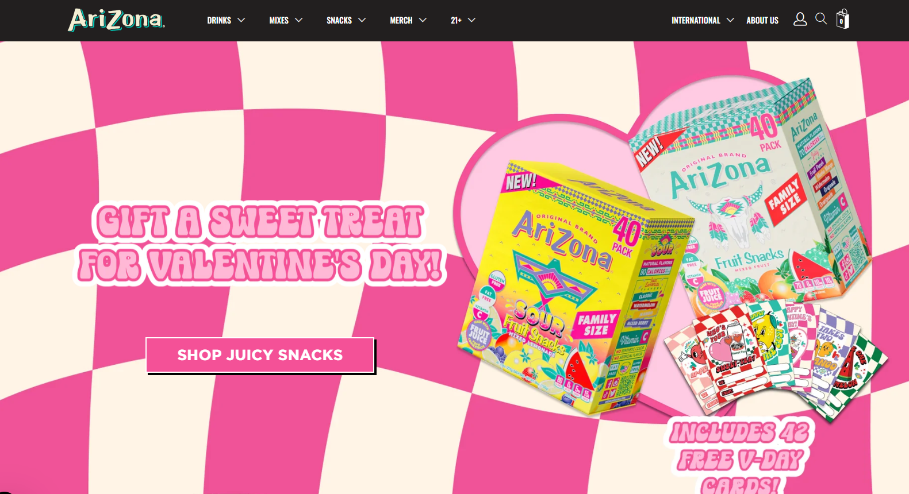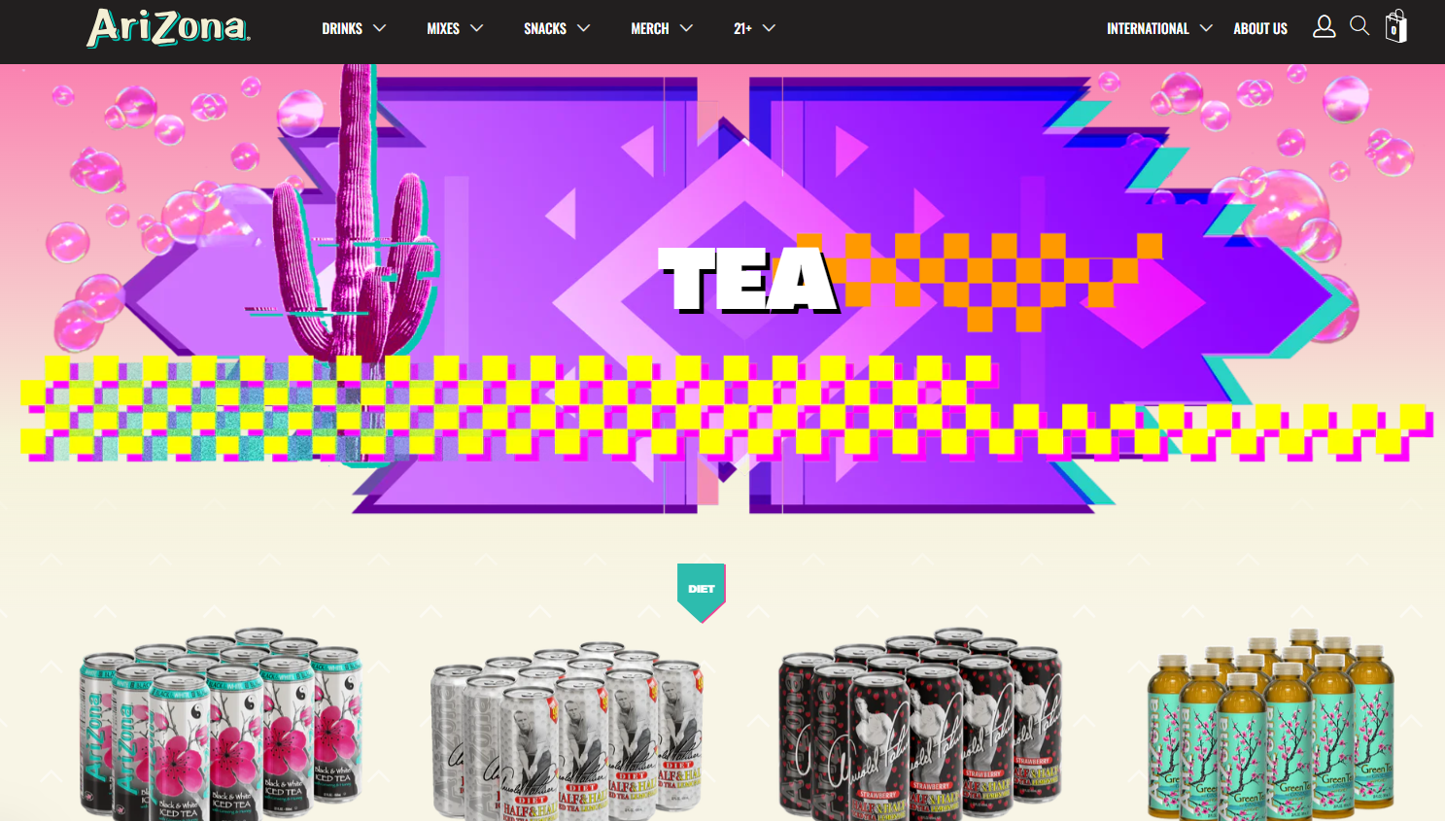

### Content Quality

The brand makes use of headings and subheadings and throughout that are easy to read with clear product descriptions. The website is also composed of straight to the point language that is clear with as minimal lengths as possible, making it straight to the point and avoiding boring the user with excessive amounts of text. The content is mostly relevant to the purpose of the website, which is selling products, specifically drinks, to an audience. On a negative aspect, it’ll depend on the user’s needs when coming across this website however, we can assume most will with the purpose of searching a brand to purchase drinks from and will find it heavily advertises merch over its drinks.

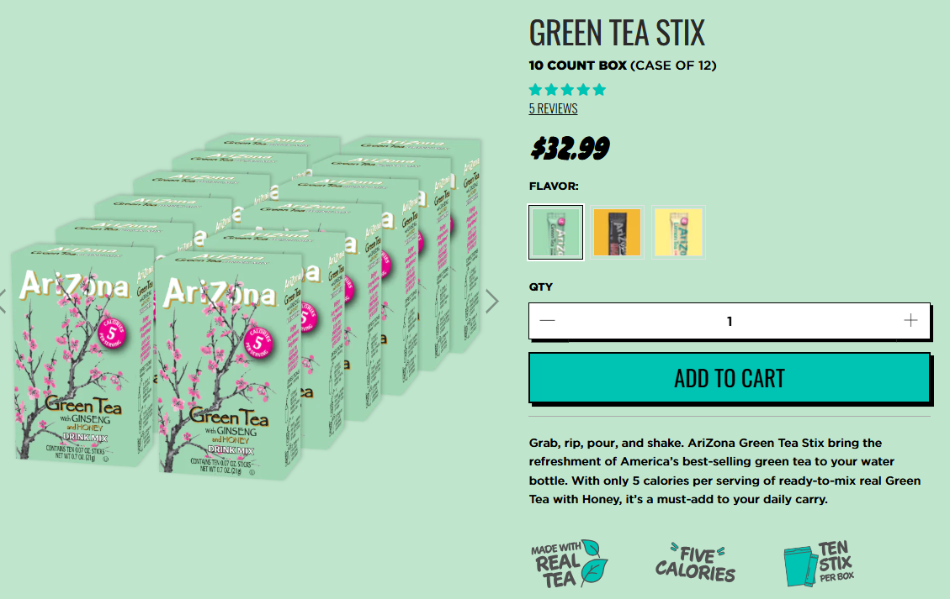

### Comparison & Conclusion

|  |  |  |
| --- | --- | --- |
| **Features** | **Pros** | **Cons** |
| * Product focused website. * Ability to purchase both drinks and merchandise. * Age-divided sections. * Product carousels. * Displays customer reviews. | * Visually appealing and engaging. * Clear organization. * User friendly. * Usage of headings and differentiative fonts that are easy to read. * Consistent design and colour palette choice. | * Homepage can be too cluttered. * Only provides translations for accessibility settings. * Heavily merchandise focused rather than the purpose of the brand. |

Overall, Arizona Tea’s website provides a fun and appealing website layout with a range of services adapting to the user’s need. However, as much as all spaces are taken up neatly, the website can feel too cluttered at times and discourage the user when they only come across merchandise listings. A feature worth pointing out this website offers is the accessibility button available on both mobile and computer devices, with a wide variety of options.

## [Mana Yerba Mate](https://en.manayerbamate.com/)

### Usability

With this website, menus are very easy to navigate. All the necessary menus are available and seen at the top of the screen as soon as the website is opened. It’s clearly labelled so that there should not be any confusion or mix-ups. The important actions/menus like “Shop”, “Learn”, “Subscribe”, “Sign up” and “Shopping cart” are incredibly straightforward and presented right at the top of the screen as soon as the website is opened. When the user clicks on the logo icon, it brings you to the homepage. The screen displays a green bubble effect that opens up and reveals the homepage, which acts as a loading indicator. The website does the same action when the user clicks on the account icon. Informative and user-friendly messages are provided if a user may enter incorrect details when logging in, e.g. “! Please adjust the following items. Incorrect email address or password". There are no search functionalities, but because the website is more of a niche market, this functionality is not necessary. The user is still able to view all products available under the “Shop” icon.



### Responsiveness

When the website is opened on a different device, e.g. on mobile or desktop, the screen adjusts to suit the screen size, maintaining clarity and readability and moving the position of each of the tabs, links or buttons, keeping them appropriately sized. When tested on both mobile and a split screen on desktop, images or animatic features are resized properly without any distortion or cropping.

### Accessibility

None of the images on the website are provided with descriptive alt text. The website also cannot be navigated only using a keyboard. It can only really be used using a joystick on mobile devices or a mouse on desktop. Although the colour contrast of the website does meet accessibility standards for readability. This is done with the use of light backgrounds and dark text, or for the text on the products, the background colour will be a darker colour with the writing being a lighter colour, like white to make it easier to read. The website also offers a the user a choice of switching between French and English to suit them.



### Aesthetics

The overall design of the website is clean, professional and visually engaging. This is seen by the animation features and information provided about the products. With each drink flavour that the user clicks on, the colour scheme of the page is different to be suited and matched to the flavour of the drink. When this is done, the colour scheme stays consistent throughout the whole page. In regard to the typography, the website used the same style of fonts throughout the website, the only difference was the font that was used for the logo/name of the website. The design of the website aligns well with the purpose of the branding. Because the website advertises healthy energy drinks, the design follows a playful design, with bright and happy colours that match each flavour of the drinks. Images and multimedia elements are of high quality and used effectively. Especially the images of the different drink flavours they have available are shown on the screen. Past the main homepage, there is sufficient white space that is utilized to avoid visual clutter. Although when advertising the different drinks available on the main page, there are a lot of visual pieces that cover the page, which don’t cause clutter, but makes the page more interesting to look at.

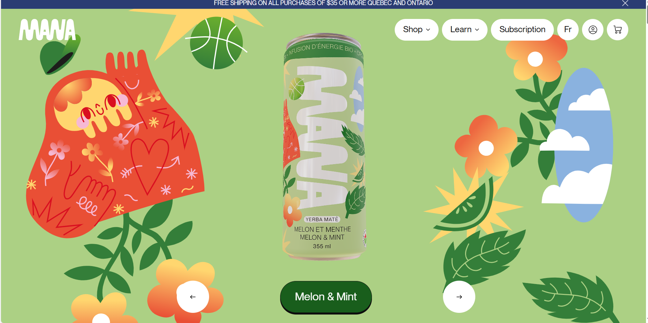

### Content Quality

The content of the website is well structured with headings and subheadings to improve readability and understanding for the user. The text conveys its information very clearly, with no use of over technical language. It is also descriptive to clearly inform the user of the products. The content provided is relevant to the target audiences' needs and interests, as the products are healthy and flavourful energy drinks, that use natural and vegan ingredients. There are no spelling, grammar or factual errors on the website. The images and animation features used throughout the website are purposeful as they effectively advertise and showcase the products to the user.

### Interactivity

The website's main interactive element is a type of mini game that the user can scroll down to at the bottom of the page, which is both intuitive and functional, but does not serve any useful purpose. Another element is seen when the user scrolls down through the website, it mimics the canned product falling as you scroll down or back up to the top. All the transitions and animations used throughout the page are smooth and purposeful as they enhance the user's experience. When the user hovers over an icon or button, it creates a hover effects, like a button being pressed. There are no interactive features like forms for this website that are validated effectively to guide user input, although this website does have a lot of interactive content on the homepage that showcases the drinks. The user can see the product move on the screen when scrolling up or down on the page, which creates an engaging experience. The user is also able to create an account and subscribe for discounts and to be notified with new products

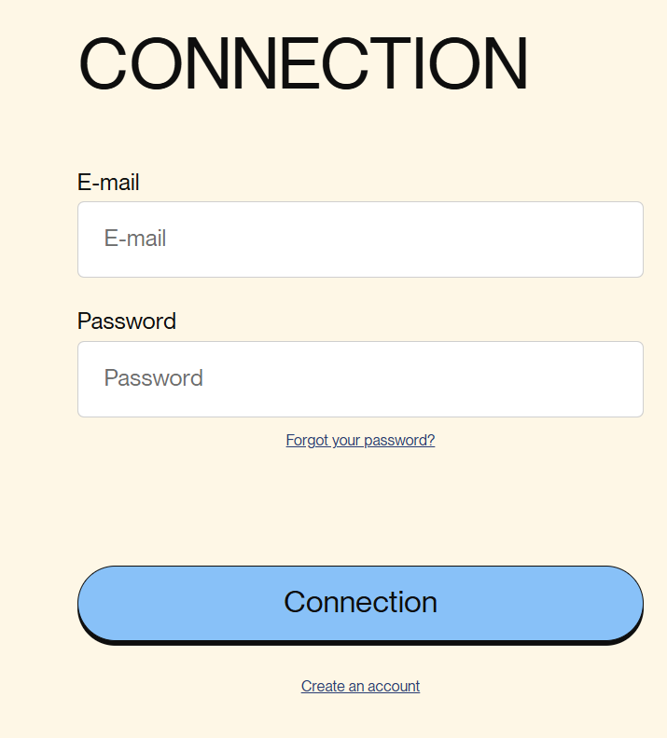

### Consistency

The website is consistent with the use of their fonts, colours and design elements across all pages. The interactions throughout the pages work as the user would expect. For example, being brought to the sign in page, or the shopping cart. Branding elements, like the logo, are displayed uniformly throughout the entire site. Their logo “mana” is seen on every product, and at the top of every page. The website also maintains consistency in layout throughout all its pages.

### Comparison & Conclusion

|  |  |  |
| --- | --- | --- |
| **Features** | **Pros** | **Cons** |
| * Hover effects * Interactive background * Carousal showcase for products * Offers French language option | * Visually appealing * Fun engaging style * Colourful palette choice * Consistent design throughout | * Inaccessible for keyboard users * Potential for visual clutter * Only offers English and French language options |

## Final Comparison & Conclusion

|  |  |  |
| --- | --- | --- |
| **Strengths** | **Weaknesses** | **Opportunities** |
| * Visually appealing with bright attractive colours, high background contrast, and consistent design. * Showcase of products through a carousal * Hover effects for tactility and interactivity * Consistent designs * Arizona Tea displayed customer reviews * Absolut website had a sense of community | * Visual clutter is common among these websites because of the overwhelming number of images and unnecessary advertisements * Absolut and Mana Yerba Mate are both inaccessible for keyboard users. * Both Arizona and Mana Yerba offer limited language options. * Some websites seemed to have a focus on merchandise rather than the products most people are there for * Absolut used awkward difficult to understand phrasing in places | * We definitely want to make our website visually appealing with bright colours, without making it too visually cluttered and keeping it consistent * We will make our website as accessible as we can for all audiences, including keyboard navigation, image descriptions, etc. * We need to make out website feel tactile and interactive by using hover effects, carousels, and other functional parts * We should make our website feel personal and authentic through the use of customer reviews and social media to foster trust and community |

# Audience and Context Research

### Introduction

Our website aims to provide a seamless, engaging and accessible experience for, but not limited to, young adults interested in healthy tea alternatives. These persona examples range from young students to the elderly, who value wellness but may be unfamiliar with the benefits of organic teas. Additionally, they often engage with brands through digital platforms but can struggle with overly complex or cluttered websites.

### User Personas

**Name:** Poppy, 26, Yoga Instructor

**Preferences:** Fun and colourful UI that is easy to use

**Goals:** To find a healthy, fun, alternative to her usual energy drinks

**Frustrations:** Having to sign up for anything

**Scenario:** You are a working woman deciding what drink to buy for a party. Navigate the website and select an appealing bottle. ([absolut.com](https://www.absolut.com/en/))

**Notes:**

Age form, newsletter form with misleading, too muc images, reading up on ddrink, borken images, cant find prchase button, misleading category, another popup despite xing, she like dseeig the cocktails, she is confused, HATES abolsut drinks, still cant find where to buy (embarassing), found products with help, sad she couldnt buy from website

*Steps:*

1. Arrived on landing page and completed age form.
2. Looked through the main page and found a drink from the small selection on the landing page that she liked after scrolling past the images.
3. Navigated to the “Drinks” category to look at other options and was confused after realizing it wasn’t where the products were, instead being social media and recipes.
4. Found the “Products” category after returning to the original website and looked over some of the many other options and found some that she wanted.

*What worked well?*  
The small selection of drinks was found quickly on the landing page and the age form was quick and efficient. The user really enjoyed seeing the social media posts and cocktails recipes on the website.

*What was confusing?*  
The user struggled a lot with navigating the website because of the unclear phrasing and overwhelming number of images. There was also an issue with having the navigate back to the main page because ‘Absolut Drinks’ is a separate website, and the user could not easily return to the previous page. The user also stated how she would have preferred if she was able to buy products on the website or if the website at least showed her where to buy said drinks.

*What improvements could be made?*  
Most of these problems are very easily fixed. The difficult navigation through the vast amount of images on the landing page could be improved by simply having less images or moving them to the bottom of the page rather than at the very top, the unclear category names could be changed to something more obvious or have an icon beside the “Drinks” category so that the user knows it is a separate social page rather than a products page, and, like the user suggested, the drink information could also have a link to a website where users can buy the drink they’re viewing.

------------------------------------------------------------------------------------------------------------------

**Name:** Margot, 73, Retired

**Preferences:** Simple, not too cluttered UI that’s easy to navigate. Search and review order features.

**Goals:** Low in sugar and healthier alternative to her typical cup of tea. Plus, a simpler site where she can manage her basket and compare ingredients.

**Frustrations:** Products lack information that’ll help her manage her condition, confusing navigation, no delivery option available, tedious to carry around.

**Scenario:** You are part of the elderly population and want an easy to use and accessible website that’ll deliver your favourite products and also make you feel more connected to the youth. Navigate the website and compare products, prices and accessibility options, then add them to the basket and assess the process. ([drinkarizona.com](https://drinkarizona.com/?srsltid=AfmBOorZHSuGF3WA84fch873MRNLtKiMhbm3r4WB9eiMz4w8G-zy7Yci))

**Notes:** Not a fan of the overall website, may feel inclined to order more/accidentally due to the cart-adding suggestion, too many colours and images, confusing, didn’t notice accessibility button, complicated homepage, prefers delivery services, need for scalable options due to poor eyesight, liked free shipping, interesting flavours, good ingredient descriptions.

*Steps:*

1. Navigated through the hamburger menu and the homepage a bit.
2. Looked through the tea section.
3. Added products to cart after looking at the ingredients and was confused by the constant product suggestions to add to the cart.
4. Went through the checkout process smoothly despite setbacks.
5. Did not find the accessibility button until after the transaction process.

*What worked well?*  
The transaction process was easy and fast to get through with clear steps and informed the user of when they unlocked free shipping. The website also provides content scaling which as an elderly person was a great feature, given she didn't have her glasses on her.

*What was confusing?*  
The constant suggestion of products for their cart threw her off most of the time as when you get to the checkout section, they look like part of your order, and you may add them without noticing. The accessibility button is barely visible, as it camouflages with the colours of the homepage on a computer. The translations faults already mentioned in the analysis of said website can lead to elderly people whose first language is not English to be frustrated. Only the accessibility settings are translated which can be useless.

*What improvements could be made?*  
The website’s UI should not cause confusion, overwhelm the user nor add product suggestions to the cart in a format that is easy to mistake with the already added ones. Considering the accessibility issues our user persona came across in this website, the icon should be replaced to provide a pop-up upon loading the website. Said pop-up will also indicate to the user where they can adjust these accessibility settings after closing it. Furthermore, regarding overwhelming interfaces, colour palettes should be reduced to staple colours that are easy on the eyes. There should also be usage of white space to ensure images are not providing a ridiculous amount of information within one scroll, leaving the user not knowing where to look first.  
  
*------------------------------------------------------------------------------------------------------------------*

**Name:** Fiona, 20, College student

**Preferences:** Colourful UI that is visually engaging, with straightforward navigation to ensure satisfaction while selecting a product and checking out

**Goals:** Finding a website that offers colourful drinks made with natural ingredients that she can substitute to her usual energy drinks that she can order online locally with a secure checkout and straightforward navigation

**Frustrations:** Having to pay extra for online shipping and complicated checkout navigation that makes her suspicious of the websites safety and payment security

**Scenario:** You are a college student looking to buy healthy energy drinks in bulk so that you don’t have to keep making orders every so often. Navigate the website to look through the products and taking note of the ingredients, choosing one that appeals to you, and adding to cart. ([manayerbamate.com](https://en.manayerbamate.com/))

**Notes:**

*Steps:*

*What worked well?*

*What was confusing?*

*What improvements could be made?*

### Context-Based Insights

**Access Environment Assessment:**

**Audience Tech Proficiency:**

# Project Goals and Objectives

## Project’s Purpose

Our website will be an ecommerce website made for selling healthy tea, but as a website it’s goal is to allow users to easily browse and purchase our stock in an intuitive and accessible manner. Our primary audience is young adults and people interested in health drinks. We want our users to be able to easily browse and purchase from our website without any complication, regardless of who they are.

## Broad Goals

* Showcase our products and allow users to add them to a cart for purchase.
* Colourful and fun to represent our brand.
* Easy to use and accessible for any user on the website.
* Responsive & functional on any platform.
* Include a search feature, login, shopping cart, and carousel to show products
* Pages for landing, about us, and products
* Detailed product descriptions for every product on the website
* Accessibility setting to turn off animations or visual clutter
  + (Pop up disability aid/form/option/opportunity/button/switch/selection)

## User-Focused Objectives

* Allow users to browse through our products to determine what they would like to purchase.
* Enable our users to add products to a cart and simply purchase them from the website.
* Let our users learn more about our company and product.

## Value Proposition

Our website will stand out because of how fun it will be, we want a very eye-catching and visually appealing website that represents our brand and that our audience will be attracted to, with accessible settings to make sure our website is fit for everyone.

# Preliminary Design

## Low-Fidelity Wireframes

## Mood Boards/Style Guides

## Site Map

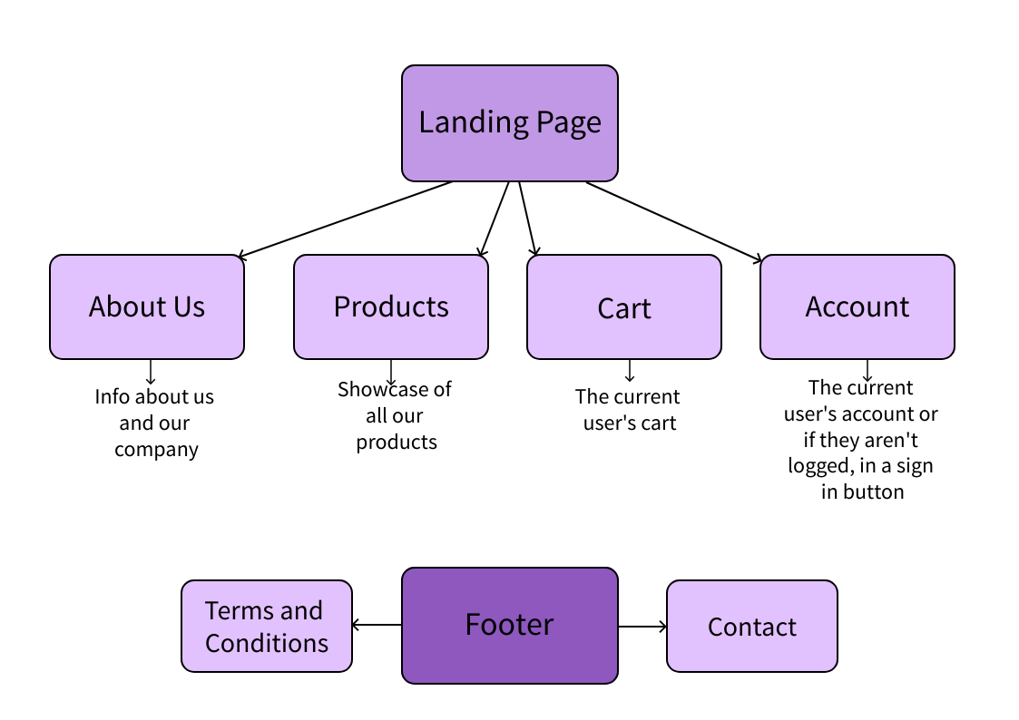

## User Flows

## Feedback